Percentile Assignment
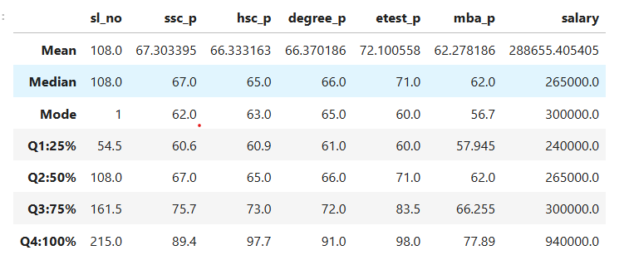
Quartile analysis helps us understand the distribution and spread of numerical data. Q1 represents the 25th percentile, Q2 the 50th percentile, Q3 the 75th percentile, and Q4 the maximum value. The differences between consecutive quartiles show how values are spread across different sections of the data.
- ssc_p
Q1 = 60.6, Q2 = 67.0, Q3 = 75.7, Q4 = 89.4.
Q2 − Q1 = 6.4,
Q3 − Q2 = 8.7, and
Q4 − Q3 = 13.7.
- hsc_p:
Q1 = 60.9, Q2 = 65.0, Q3 = 73.0, Q4 = 97.7.
Q2 − Q1 = 4.1,
Q3 − Q2 = 8.0, and
Q4 − Q3 = 24.7.
- degree_p:
Q1 = 61.0, Q2 = 66.0, Q3 = 72.0, Q4 = 91.0.
Q2 − Q1 = 5.0,
Q3 − Q2 = 6.0, and
Q4 − Q3 = 19.0.
- etest_p:
Q1 = 60.0, Q2 = 71.0, Q3 = 83.5, Q4 = 98.0.
Q2 − Q1 = 11.0,
Q3 − Q2 = 12.5, and
Q4 − Q3 = 14.5.
- mba_p:
Q1 = 57.945, Q2 = 62.0, Q3 = 66.255, Q4 = 77.89.
Q2 − Q1 = 4.055,
Q3 − Q2 = 4.255, and
Q4 − Q3 = 11.635.
- salary:
Q1 = ₹2,40,000, Q2 = ₹2,65,000, Q3 = ₹3,00,000, Q4 = ₹9,40,000.
Q2 − Q1 = ₹25,000,
Q3 − Q2 = ₹35,000, and
Q4 − Q3 = ₹6,40,000.
Conclusion:
The quartile analysis reveals differences in the distribution and variability of academic scores and salaries. Among the academic variables, etest_p has the largest interquartile range (23.5), indicating greater variability in the middle 50% of scores, while mba_p has the smallest interquartile range (8.31), indicating that its middle 50% of scores are more closely grouped. The ssc_p, hsc_p, and degree_p scores show moderate variation within their middle 50% ranges. In the salary column, the middle 50% of salaries fall between ₹2,40,000 and ₹3,00,000, giving an interquartile range of ₹60,000. However, the maximum salary of ₹9,40,000 is considerably higher than Q3, suggesting a wide upper-end salary spread and the possibility of unusually high salary values. Overall, quartile analysis provides useful insights into data distribution, variability, and potential extreme values.

